

Submitted By:
Muhammad Zain Rasheed – 2025-CYS-153
Assignment:
Lab No. 1
Submitted To:
Sir Mubashir

For the fulfillment of,
Object-Oriented Programming Lab
Department of Computer Engineering
University of Engineering and Technology, Lahore

Task No. 1:
Change the Factorial code discussed in class so that it shows proper messaging in case of negative numbers.
Solution:
import java.util.Scanner;
public class Main {
public static void main(String[] args) {
Scanner scanner = new Scanner(System.in);
System.out.print("Enter a positive integer: ");
int number = scanner.nextInt();
if (number < 0) {
System.out.println("Factorial is not defined for negative numbers.");
} else {
int result = 1;
for (int i = 1; i <= number; i++) {
result *= i;
}
System.out.println("The factorial of " + number + " is: " + result);
}
}
}

Output:
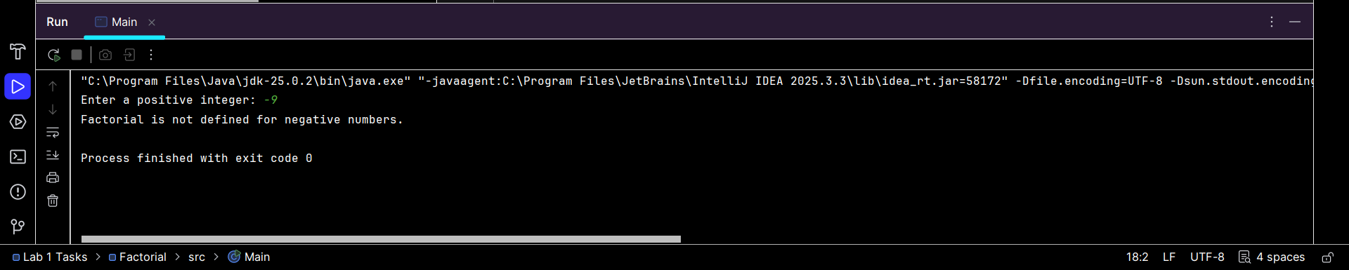

Task No. 2:
Change the Series_Generator such that it can generate both increasing series or decreasing series depending on the starting and ending values.
Solution:
import java.util.Scanner;
public class Main {
public static void main(String[] args) {
Scanner sc = new Scanner(System.in);
System.out.print("Enter starting value: ");
int start = sc.nextInt();
System.out.print("Enter ending value: ");
int end = sc.nextInt();
System.out.println("Generated Series:");
if (start < end) {
for (int i = start; i <= end; i++) {
System.out.print(i + " ");
}
}
else if (start > end) {
for (int i = start; i >= end; i--) {
System.out.print(i + " ");
}
}
else {
System.out.print(start);
}
}
}

Output:
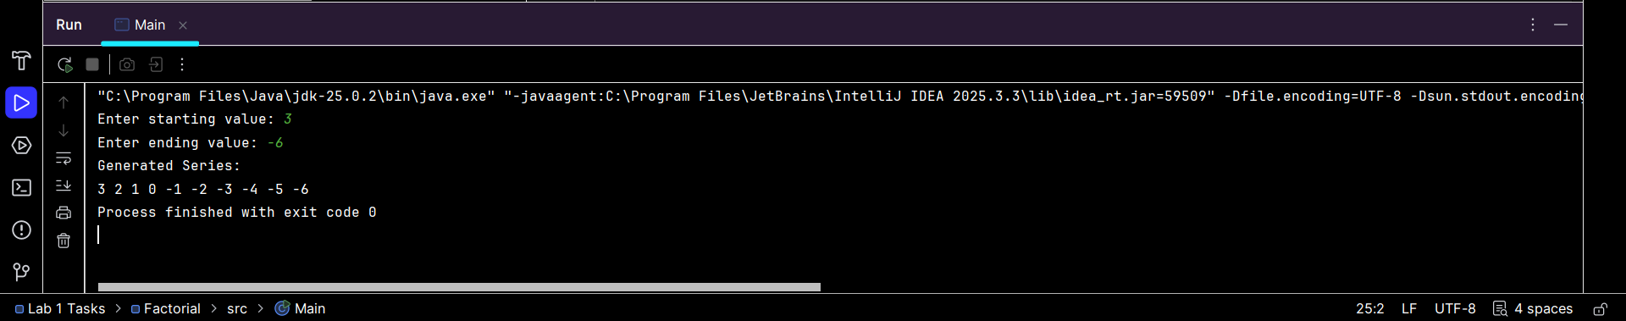

Task No. 3:
Write a Program that takes year as an input from user and determine if it’s a leap year or not. Sample input
>>>
Enter Any Year: 1940
It is a leap year
Solution:
import java.util.Scanner;
public class Main {
public static void main(String[] args) {
Scanner sc = new Scanner(System.in);
System.out.print("Enter Any Year: ");
int year = sc.nextInt();
if (year % 4 == 0){
System.out.println("It is a leap year");
} else {
System.out.println("It is not a leap year");
}
}
}

Output:
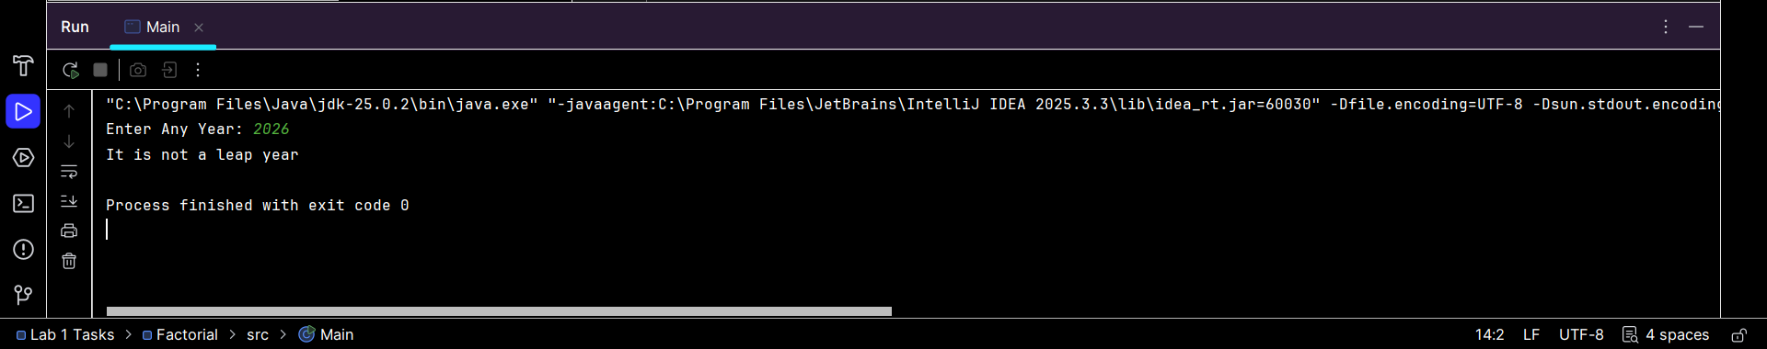
Task No. 4:
You are interested in calculating your electricity bill of your home. You know the unit consumption of your home. Billing criteria for electric company is that it charges 5 Rs/ unit for first 100 units, next 100 units are charged at 7 Rs/unit and above that charge is 15 Rs/unit. As input, you get total_Units consumed and generate bill.
Sample input
>>>
Enter Units Consumed: 150
Bill: 850
Solution:
import java.util.Scanner;
public class Main {
public static void main(String[] args) {
Scanner sc = new Scanner(System.in);
System.out.print("Enter Units Consumed: ");
int units = sc.nextInt();
int bill = 0;
if (units <= 100) {
bill = units * 5;
}
else if (units <= 200) {
bill = (100 * 5) + (units - 100) * 7;
}
else {
bill = (100 * 5) + (100 * 7) + (units - 200) * 15;
}
System.out.println("Bill: " + bill);
}
}

Output:
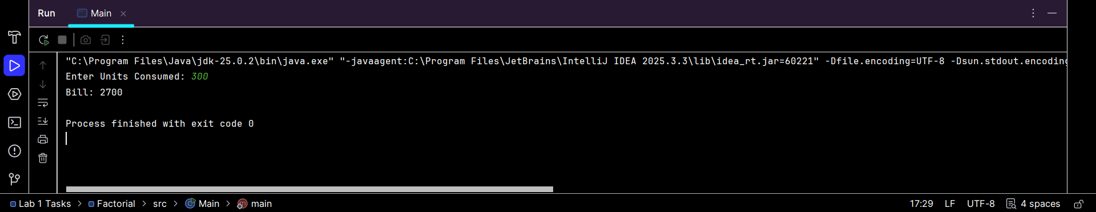

Task No. 5:
Write a program that takes an integer n from command-line arguments and uses a while loop to compute the number of times you need to divide n by 2 until it is strictly less than 1. Print the error message “Illegal input” if n is negative.
Sample input
>>> n: 8 Div: 4
>>> n: 4
Div: 3
Solution:
import java.util.Scanner;
public class Main {
public static void main(String[] arg)
{
Scanner sc = new Scanner(System.in);
System.out.print(">>n: ");
float n = sc.nextFloat();
int div = 0;
while (n > 0.99)
{
n = n / 2;
div++;
}
System.out.print(">>div: " + div);
}
}

Output:
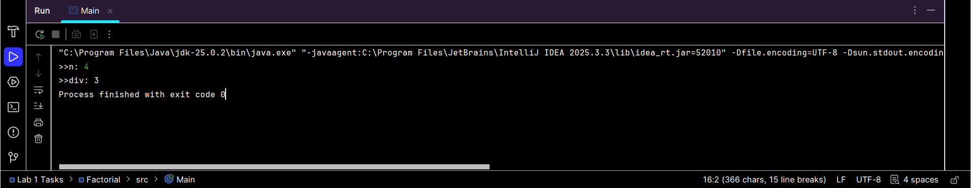

Task No. 6:
Write a code that takes a number value from user and displays the inverse of it. Number can be of any length.
Sample input
>>>
Number: 151
Inverse: 151
>>>
Number: 1567
Inverse: 7651
Solution:
import java.util.Scanner;
public class Main {
public static void main(String[] args) {
Scanner sc = new Scanner(System.in);
System.out.print("Enter Number: ");
String num = sc.nextLine(); // read as string for any length
String inverse = "";
int i = num.length() - 1;
while (i >= 0) {
inverse += num.charAt(i);
i--;
}
System.out.println("Inverse is: " + inverse);
sc.close();
}
}

Output:
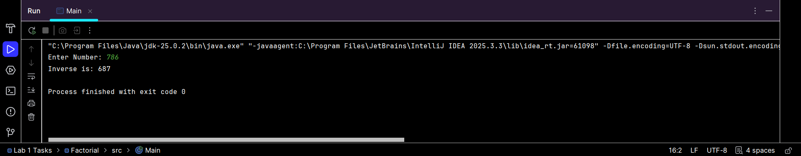

The End

